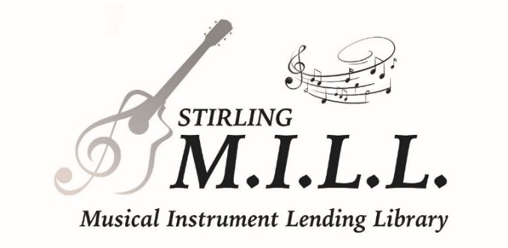
Patron Registration

Card Code:

Expiry/Renewal:

Name: ________________________________

Parent/Guardian (if applicable):

______________________________________

Address: ______________________________

______________________________________

City: _________________________________
Post Code: ON ________ ________

Municipality: __________________________

Telephone: _______ - _______ - __________

Cell: _______ - _______ - __________

Email: ________________________________

Social media: ___________________________

MILL Patron 1 □ $30 per annum – 1 instrument loan at a time/card
MILL Patron 2 □ $50 per annum – 2 concurrent instrument loans/card
MILL Patron 3 □ $70 per annum – 3 concurrent instrument loans/card
Payment to Stirling MILL by cash or cheque, or by e-Transfer to treasurer@stirlingmill.ca
An ‘instrument loan’ equates to borrowing one instrument plus associated support gear. Example: an electric guitar loan might (but does not necessarily) include an instrument cable and a guitar amplifier.
All instrument loans are issued on a 6-week basis (excepting 12-week loans for drum kits). A reminder email with the return due date will be sent 2 days before the loan is due. Loan renewals are at the discretion of Stirling MILL. Contact curator@stirlingmill.ca to confirm the instrument is maintained in good condition and no ‘hold’ placed on the item by another MILL Patron. An extended loan period may be available for music students registered in school or private lessons.

Pay-it-forward Option – Some Stirling MILL Patrons elect to donate all or part of the cost toward a Patron Registration for someone who may find paying the full amount a challenge.
Eligibility for support from the MILL’s Pay-it-forward Fund is at the discretion of the Stirling MILL. Please ask the MILL Staff or Librarian who assists your registration.

Fundraising to support Stirling MILL programming is an ongoing challenge. Financial contributions are always welcome. A tax receipt can be available for Donations by cheque of $100 or more.
If you wish to contribute, please fill in the amount you would like to offer in the space below.
Yes! □ I would like to make a donation of $_______ to support the Stirling MILL.
Want to get involved...? Community-based and community-focused, volunteers are the lifeblood of our organization. Ask what we need and let us know what you can offer.
(over...)

Photo ID (Driving License, Citizenship, Student ID, Passport, Military ID, etc.)

# ________________________________________________________

Date of Birth (year/month/day) ________/____/____

Under 18 □ Senior □
Address confirmation (Public Library Patron, mail to your residential address, property tax docs, lease, etc.)

_________________________________________________________

Registration fee: cash □ cheque □ e-transfer □

Military/veteran or family □

- An Instrument Loan may include a ‘primary’ musical instrument plus supplementary items; for example: 1 electric guitar + 1 electric guitar amplifier + 1 patch cable = 1 instrument loan.
- A ‘MILL Patron 1’ card allows only one Instrument Loan at a time. ‘MILL Patron 2’ status allows up to two concurrent Instrument Loans. ‘MILL Patron 3’ allows up to three concurrent Instrument Loans.
- Instrument Loans are for a period of 42 days (6 weeks). Note: drum set loans are for 12 weeks. Loan renewals may be allowed conditional on no hold having been placed on the instrument.
- Request for loan renewal should be made either in person at the MILL in Stirling, by email to staff@stirlingmill.ca or the portal on our website: https://stirlingmill.ca/instrument-library/policies-returns/ It must include a written declaration identifying (all) the item(s) by their ‘Call Number’, confirming they are being maintained with care and in good condition. MILL staff may request inspection of the instrument. (Damage to an instrument in the Patron’s possession should be reported to the MILL without delay.)
- Instruments on loan may be returned to the MILL in Stirling or to any of the MILL’s Partner Libraries during that location’s regular operating hours.
- Check Out, Returns and Renewals of all instrument loans are processed through the Stirling Public Library operating system.
- Overdue Charges will be assessed at: $1 per day per ‘instrument loan’ ($5 per week) up to a maximum of $60.

The undersigned is responsible for all materials borrowed from Stirling M.I.L.L. and agrees to abide by the rules and regulations of the Stirling Musical Instrument Lending Library.

- Parents/guardians are responsible for materials borrowed by those in their care under age 18.
- Changes of address and/or contact information must be reported immediately.

I (the undersigned) hereby acknowledge responsibility for the care of all items on loan from the Stirling MILL and agree to return same no later than the return due date. I understand that I will be held responsible for replacing any item or for its replacement cost as determined by Stirling MILL if it is not returned, or if it is damaged beyond repair. By signing this document, I agree to assume all responsibility for loss or damage to property on loan from the Stirling MILL. I hereby release, waive and discharge the Stirling MILL, as well as their employees and volunteers, from liability or responsibility for any harm due to accident or negligence involving the instruments/equipment. In the event of loan delinquency, I understand that Stirling MILL may share my registration information with third parties for the purposes of recovery of any and all MILL properties. Costs associated with the recovery of said properties may be payable by me. I understand and accept that my failure to abide by the provisions of this contract may result in legal proceedings against me.

I acknowledge and confirm that I reside within the Stirling MILL’s service area or within 30 km of a MILL Partner Library, I have read this document & agree to abide by all conditions herein:

Signature: ________________________________________________ Date: ____________________

Processed by: ____________________________ Data Entry by: ____________________________

Notes:

